Security assesment include risk assesment , threat assesment and vulnerability scan
TCP Syn scan uses first two steps of tcp handshake
TCP ACK scan sends an ACK packet, simulating a packet from the middle of an already established connection.
```bash
git init
```

- Waqas
- Saleem
1 | 2
3 | 4

data protection is ensured via smooth backup operation of org.
if cost is not matter than best option is use of multiple equipment for any process.
Authenticated scans can read configuration information from the target system and reduce the instances of false positive and false negative reports.
privelleged accounts are first to be auditted for access review
. ATT&CK and the Cyber Kill Chain are tools used to conduct threat intelligence.openVAS is vulnerability scan tool
mutual indemnification is a contractual obligation that each party will compensate in each loss or profit.03125556112
synthetic transactions and test coverage analysis to be studied
attacks of databases are done using 443 and 80 ports not 1521 or 1433 port
SOC1 : Financial reports and control effect on finance
SOC2 Type 1: security controls implementation
SOC2 Type 2 : effectiveness of controls
SOC3 :SOC 3 engagements assess the organization's controls that affect the security and privacy of information stored in a system. The results of a SOC 3 audit are intended for public disclosure
Branch coverage evaluates whether every if statement has been executed under all if and else conditions. Condition coverage tests whether every logical test in the code has been executed
Synthetic transaction in inputs entered in webpages to see functional performances.Scripts containing routine activity with known results and then compares the actual results of executing the script with expected outcomes.
The management review and approval process ensures that each account was appropriately authorized and remains necessary to meet business needs.
Review a random sample of 20% of accounts if 100% review is not possible.
independent auditors should be engaged for audit.
Remember that detective, recovery, and corrective controls are enforced after an incident is present. However, deterrent, directive, preventive, and compensating controls are applicable before an incident takes place.
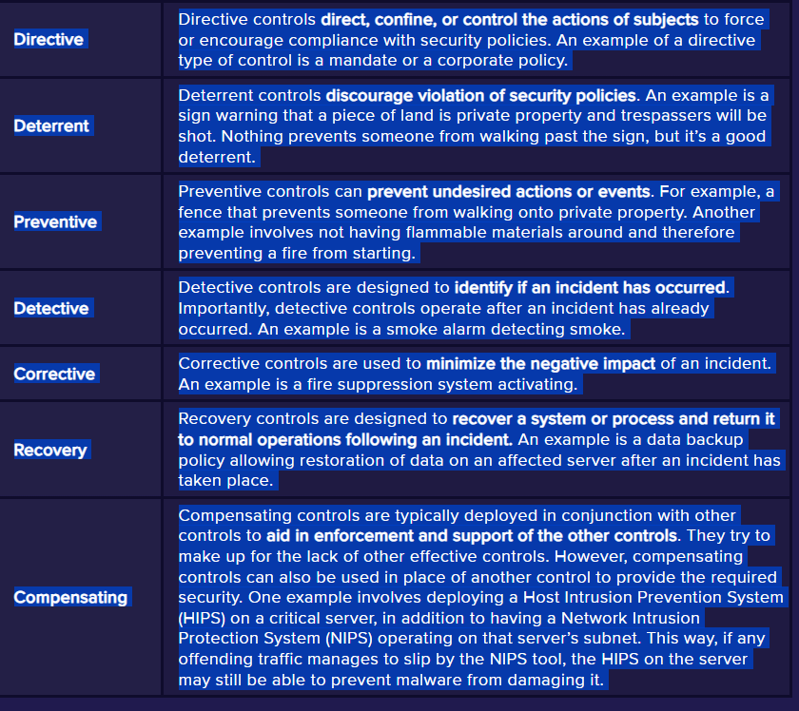

Common Configuration Enumeration (CCE) provides a naming system for system configuration issues during vulnerabilityu analysis. Common Vulnerabilities and Exposures (CVE) provides a naming system for describing security vulnerabilities. Common Platform Enumeration (CPE) provides a naming system for operating systems, applications, and devices
10.0.0.0/8 will scan any IP address beginning with 10.
Vulnerability scanners can check systems to ensure they are up-to-date with current patches
sqlmap identifies database vulnerabilities.
NIST 53a is assesment of controls whiel 53 is description of control
on premises cloud infra is owned by company and it can also lease its services of hardware to other recipients.
Fagan inspection model uses the six formal steps of planning, overview, preparation, inspection, rework, and follow-up to conduct a formal code review process.

